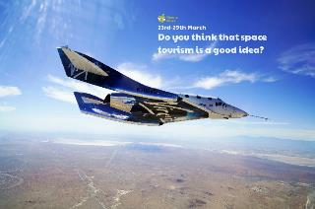

Look up some ‘space music’. Can you describe what you hear? How does it make you feel? Can you move to it? Can you create a dance to it?

Find out which countries have had astronauts visit space. Can you locate these places on a world map? Which country has had the most people in space?

Design and make your own spaceship using materials you have at home. What will you use to join your materials? What colour/design will your spaceship be?

Find out about our solar system. How many planets are there? What are they called? Can you find a rhyme to remember their position from the sun?

**Learning from Home**

Use the ideas below, alongside this week’s resource, to support your home learning.

Read and research about space travel throughout history. Can you find out who was the first person to travel into space? What year did the first person walk on the moon? What else can you find out?

Design and make a paper aeroplane. Can you measure the distance it flies? Can you record this measurement in both metres and centimetres? Can you alter the design to make it go further?