Weekly Art Activity
If you are feeling creative have a go at these art and DT activities. There will be a new one each week. You might find some easier than others or you might not fancy doing them every week – that’s Ok!
If you haven’t got what you need to complete the task, don’t panic – see if you can substitute equipment or materials for things you do have.
Let me know how you get on – email pictures to jcooper8nr5@nsix.org.uk

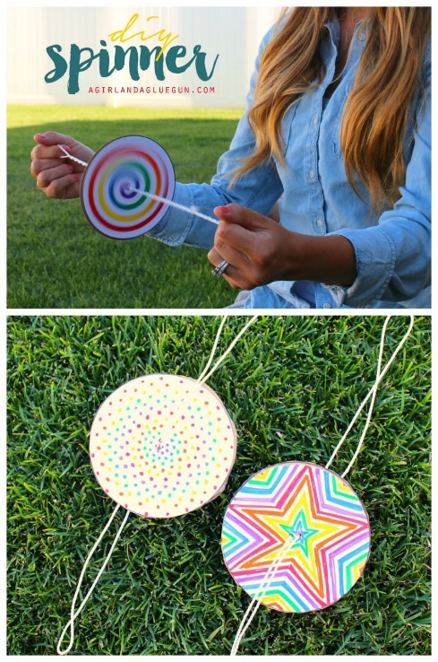
DIY Paper Spinner
Craft up a few really fun spinners–You spin them and they hum! It’s super fun and most things, you probably already have around the house! Here’s the how-to instructions.

Supplies:
- twine
- cardboard circles
- printer paper
- markers
- scissors
- glue sticks

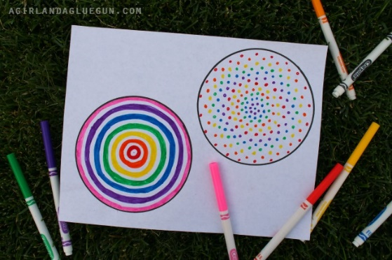
1. Make 2 circles onto your printer paper
2. Add colour to these circles, the more colourful, the more fun it is to see as it spins…
3. Cut out paper circles.
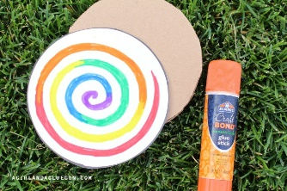
4. Use these to trace on a cardboard box and cut out 1 cardboard circle.
5. Glue on the paper circles to the cardboard, (one on each side!)
6. Poke two holes right in the centre of the cardboard circle.
7. Take a piece of twine, or rope, about 28 inches long. Run the rope through the holes and tie a knot.
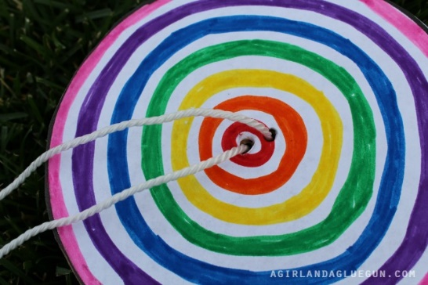

Time to play with your DIY Paper Spinner
Take a piece of rope in each hand with the circle in the middle and go in circles to get the rope twisted.
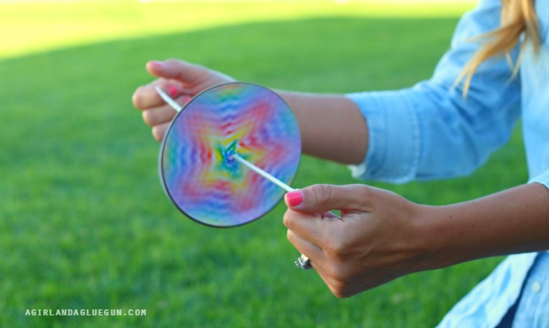
Now you pull…relax…pull…relax. IF you do it right, the spinners make a humming noise!!!!

