Weekly Art Activity
If you are feeling creative have a go at these art and DT activities. There will be a new one each week. You might find some easier than others or you might not fancy doing them every week – that’s Ok!
If you haven’t got what you need to complete the task, don’t panic – see if you can substitute equipment or materials for things you do have.
Let me know how you get on – email pictures to jcooper8nr5@nsix.org.uk

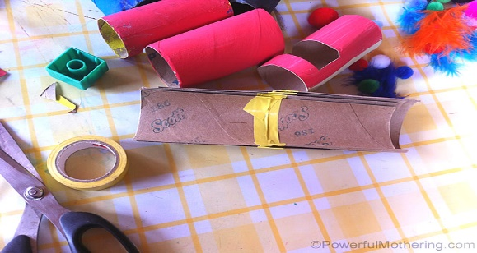
DIY Marble Run from Toilet Rolls
- 11 Toilet paper rolls
- Cardboard base
- Tape
- Paint
- Glue
- Marbles / Pom Poms
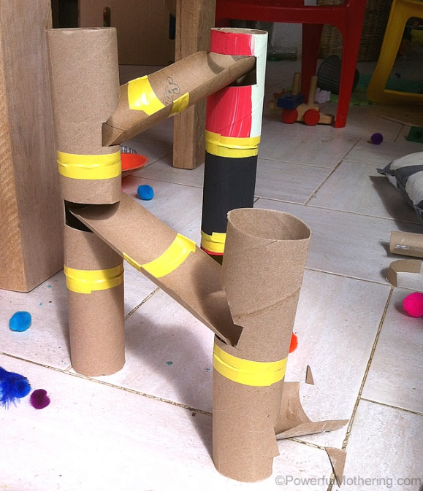
Create towers using the toilet rolls – they could be one roll high, two or three – use tape to connect them.
To connect the towers cut 3 toilet rolls in half longways and tape them together to make shoots.
Next, cut holes in the towers for the shoots to rest in, making sure that it is tilted downward to encourage the marbles to roll down.
For the base use the side of a cardboard box, mark where you want the towers then glue them down.
Fix in the shoots and test using a marble or pompom. Adjust if necessary!
You might like to paint your marble run, give it a name, time how long it takes for the marble to drop, make it bigger or taller….

