Children’s Mental Health Week: Week Beginning: 1st February: Theme – Express Yourself

Art  Express yourself – in how many different ways can you express your emotions?  Drawing – splashing paint or taking your pencil for a walk?  Sports - Dancing, running, football.  Music – singing, dancing  Being creative in other ways | How do I?  What do you do when you’re feeling sad or angry? What helps you?  What do you do when you’re feeling happy or proud?  Remember these bits of advice for when a friend might need them. | A-Z  Can you name an emotion for each letter of the alphabet? | What is mental health?  https://www.youtube.com/  watch?v=nCrjevx3-Js&feature=emb_logo | How can you be a good listener?  Make a poster to help give some top tips about how to be a good listener?
Identify  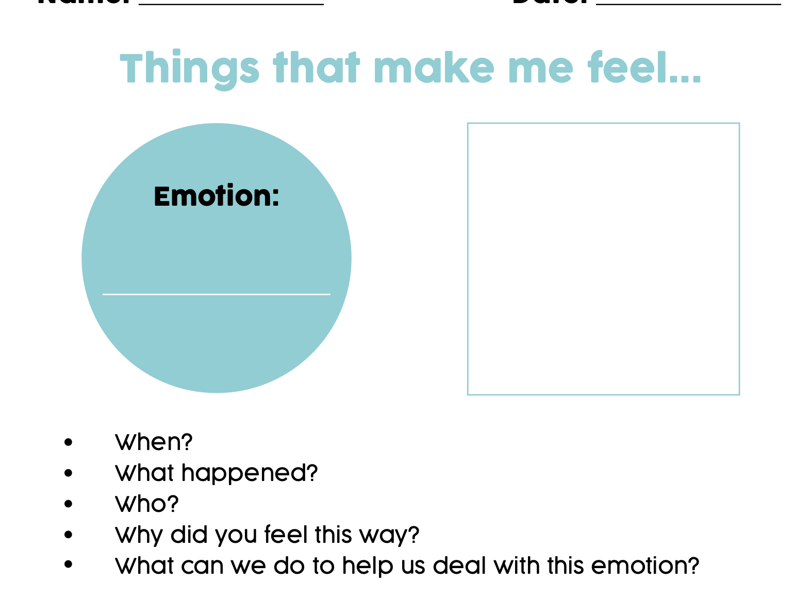 | Identify part 2  Take some time to reflect: Can you pin point the ‘trigger’ for your emotion. For example: I usually feel frustrated when I’ve forgotten where I’ve put my favourite toy. | Writing  Start writing a diary to express yourself. A diary is a safe place to keep your thoughts. It’s okay to write down negative things in it too. Or write a letter to yourself:  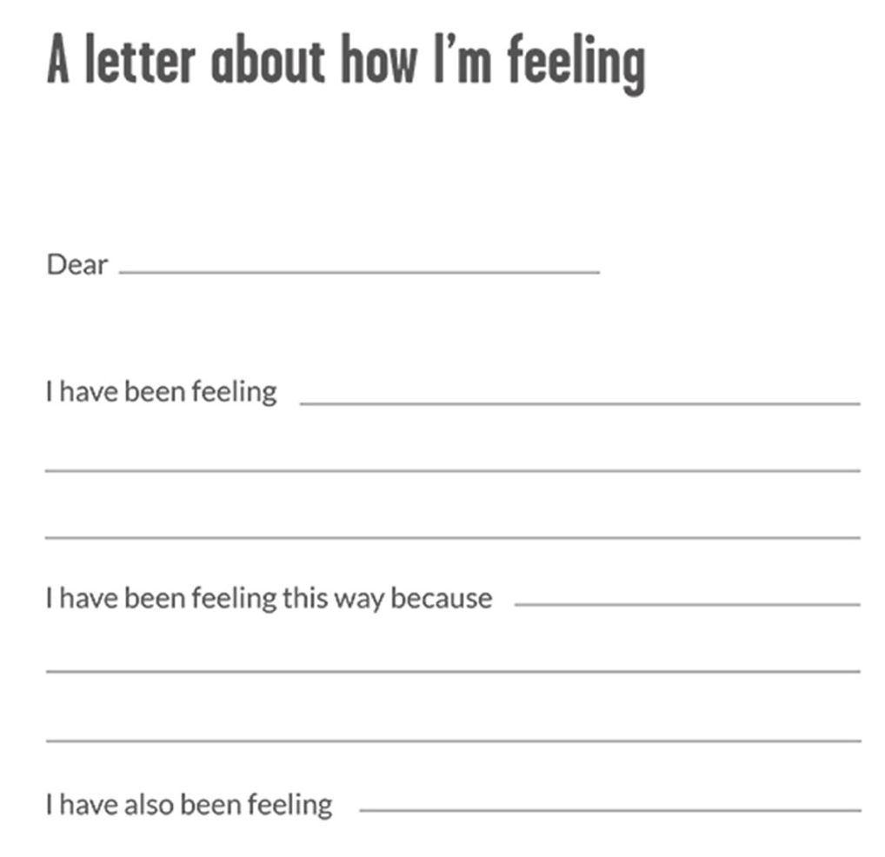 | Journaling  Look at the PowerPoint for some top tips on Journaling | Talking Time  Find a time to turn off all devices and talk. Share the best bits of your day or your favourite memories. Talk about the things that are worrying you or you feel unsure about. It’s good to talk.
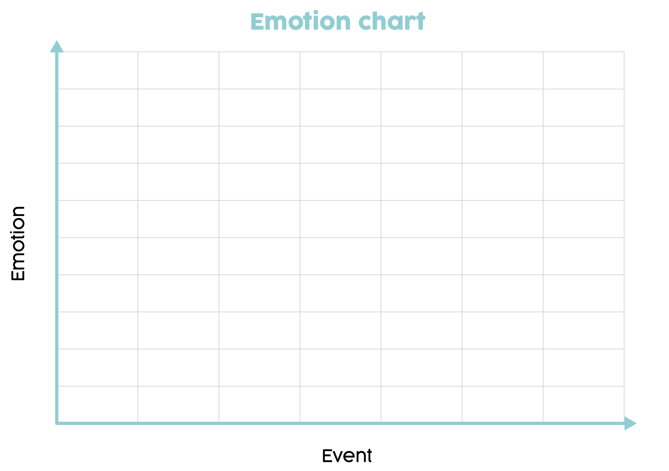  Emotion Tracking | Letting off Steam  What do you need to do when you feel like you need to explode?  What strategies can you do in the classroom that is respectful? What strategies can you use when you’re at home to let go? | Random Acts of Kindness  https://www.randomactsofkindness.org  Scroll to the bottom where you’ll find socially distanced kindness resources. Find an idea you like.  Can you show an act of kindness today? | Cool down corner  Make yourself a safe corner or space where you can feel your emotions.  You might keep your favourite toy here to cuddle.  https://classroom.thenational.academy/lessons/cool-down-corner-6hjkae?activity=video&step=1 | Happiness Box  Make yourself a box of all the things that make you feel happy and safe. You can look at this when you are feeling scared or worried.  https://classroom.thenational.academy/lessons/keep-calm-and-carry-on-6cu34c?activity=video&step=1
Design an outfit that expresses who you are  Think about your favourite colours, activities and what makes you happy. Create this outfit on a piece of paper or another way that you like | Music  Put on your favourite music and respond to it through dancing, drawing or just listening. | Art  Draw a picture of yourself and write on it all the things you like about yourself. | Outdoors  Spend time with your family – play games, go for a walk or doing something fun together. | Create  Create (by making or drawing) a place you would like to visit.

Pick some activities and videos to watch over the course of the week to help you, express yourself and keep calm.

