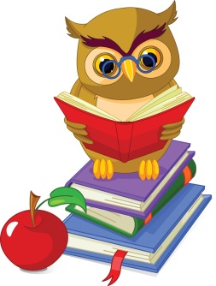
World Book Day 2017
Old Catton Junior School

It’s that time of year again, when we celebate all of the wonderful books that play such an important part in our lives!
This year, we have a number of events happening in school to celebrate World Book Day:

- Pay £1 and dress up as your favourite book character

- Back by popular demand – a book themed cake sale! This time, you can really get your creative baking hats on and think of any theme you wish for your yummy treats – as long as they are book related!
(cakes to be brought into school from Tuesday 28th February)

- New to this year – if you have any spare books lying around the house and wish to donate them for our OCJS book sale, they will be gratefully received. We will then by hosting a book sale after school on Thursday 2nd March. Books can be brought into school and handed to Miss Emrick any time from this week. Thank you!
