Dear Parents and Carers,

**RE: Poetry Reading Week!**

After half term, we will be learning all about poetry in our Reading Week. I would like every child to have the opportunity to write in their own poetry book during this week – and afterwards too if they would like to.

We will give every child an exercise book and would like them to cover it to make it their own. This is not a formal book and the children could use wrapping paper, stickers, doodles and drawings to cover the book and make it their own. They will also need to put their name clearly on their book.

Please can you encourage them to do this over half term and then bring the book back to school, ready to use it during the week we are focusing on poetry.

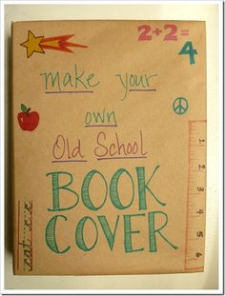



During the poetry reading week we also have the opportunity for you to come in and work alongside your child in school on Wednesday 22nd February from 2pm-3:15pm. We look forward to seeing you there if you can make it.

On Thursday 23rd February, in the afternoon, the children will be visited by the Poet Karl Nova. I am sure this visit will be very exciting – bringing to life poetry for the children.

Mrs K Connelly

Head of School

Old Catton Junior School