2022-2023
The Nebula Federation
Old Catton Junior School

Curriculum Skills and Progression Modern Foreign Languages
Modern Foreign Languages is intended to be a subject in which all children are given chance to flourish and are given opportunities to be the very best they can be.
MFL very much fosters religious literacy and different beliefs and much like the story of bible parable of ‘The Lost Sheep’ aims for children to find it easier to love one another and not feel lost, by understanding a multitude of languages.
We hope this will lead to us all being part of a global community, speaking the language of love. MFL provides joy to children learning how others (including many of our own EAL students) speak and gives them an ability to show tolerance.
‘Spirituality is the bitter-sweet yearning for beauty, truth, love and wonder beyond ourselves. It is a longing we pursue together and a treasure we glimpse in ourselves and one another and seek beyond us into eternity. It is life in all its fullness.’ Nebula Spirituality Statement

To sum up the importance of MFL, as Ludwig Wittgenstein once said “les limites de ma lange sont les limites de mon monde’’ (The limits of my language are the limits of my world).

Age Related Coverage
FOREIGN LANGUAGES: AGE RELATED STATUTORY COVERAGE
LANGUAGES: STATUTORY PROGRAMME OF STUDY FOR KEY STAGE TWO ONLY
Pupils should be taught to:
- listen attentively to spoken language and show understanding by joining in and responding
- explore the patterns and sounds of language through songs and rhymes and link the spelling, sound and meaning of words
- engage in conversations; ask and answer questions; express opinions and respond to those of others; seek clarification and help
- speak in sentences, using familiar vocabulary, phrases and basic language structures
- develop accurate pronunciation and intonation so that others understand when they are reading aloud or using familiar words and phrases
- present ideas and information orally to a range of audiences
- read carefully and show understanding of words, phrases and simple writing
- appreciate stories, songs, poems and rhymes in the language
- broaden their vocabulary and develop their ability to understand new words that are introduced into familiar written material, including through using a dictionary
- write phrases from memory, and adapt these to create new sentences, to express ideas clearly
- describe people, places, things and actions orally and in writing
- understand basic grammar appropriate to the language being studied, including (where relevant): feminine, masculine and neuter forms and the conjugation of high-frequency verbs; key features and patterns of the language; how to apply these, for instance, to build sentences; and how these differ from or are similar to English.

At Old Catton, the children study Spanish, German and French over the four years that they are with us. The long term plan for this can be found in Appendix 1. We use several resources to teach our MFL units, including (but not limited to) Felix und Franzi for German, Rachel Hawkes for Spanish and Rigolo for French. The details for these schemes are detailed in Appendix 2. Within these units, teachers have the freedom to supplement the lessons with their own knowledge and resources as they see fit for each class, adapting to their needs. However, they ensure that the lesson aims and key content for each lesson is always followed. Our schemes are followed to ensure that we hit the curriculum aims (as set out for the 2014 National Curriculum).
Due to the nature of our MFL lessons, a lot of the work completed is done so orally. As a result, we have a mixture of evidence used. For example, Teacher’s may choose between videos (kept digitally) and intermittent written work to complete writing criteria. Teachers complete an assessment grid for each MFL subject, an example can be found in separate document (French). A childs grade is entered via the foundation assessment excel grid each term.
In recent years, we have had more children enrolling at Old Catton with English as an additional language. We have therefore aimed to celebrate all the languages within our school. In future I have planned an International Day to take place, during which the children will have a taster of 4 brand new languages from around the world, in addition to a session in which they can explore the different cultures within their class even further. The plan for this can be found in Appendix 4. We also encourage the children to respond to the register in a different language, if they wish, and have signs around the school labelling key areas in the languages spoken by the children, in addition to the French, Spanish and German that we teach the children.
Covid had a huge impact on school and subsequently we created a ‘catch up document’ for MFL. This can be found separately.
In February 2022 we held a Spanish day for all student in lower school. During the day children learnt how to dance the Flamenco, created a card alongside a native Spanish speaker, created a Miro inspired piece of art, listened and appraised Spanish language music and even made some Spanish cake.
Being a Church of England school, we take this ethos into account as part of MFL. The MFL Christian distinctiveness statement can be found on the front of this document.
SEN is very much catered for here at OCJS. You can read the MFL SEN provision document again to be found separately.

Skills Maps
Skills Map – Modern Foreign Languages
Year 3/4 – MFL
Listening and Responding | Speaking | Reading and Responding | Writing Opportunities  (pictures used to support)
- Do they understand a range of familiar statements already taught?  - Can they repeat and sing well-known songs in the required language?  - Do they understand instructions, messages and dialogues within short passages?  - Can they identify and note the main points and give a personal response on a passage?  Spoken at near normal speed with no interference. May need items or short sections repeated.  Short passages to retrieve information. | - Can they give short and simple responses to what they see and hear? e.g. Conversational languages including greetings, number responses, taught vocab, colours, what’s the date?  - Can they have a short conversation where they are saying 2-3 things? Conversational, visits, hobbies etc  - Can they name and describe people and places?  - Can they name and describe simple classroom objects/colours?  - Can they use (set) phrases?  - Can they use short phrases to give a personal response?  Pronunciation may still be approximate and delivery hesitant, but their meaning is clear.  Although they use mainly memorised language, they occasionally substitute items of vocabulary to vary the questions or statements. | - Can they read and understand single words and short phrases and give a response? (true of false, multiple choice, answer simple retrieval questions)  - Can they read aloud single words and phrases independently?  - Can they use a bilingual dictionary or glossary to look up new words? | - Can they copy a short familiar phrase?  - Can they write or word-process set phrases we use in class?  - Can they write 2-3 short sentences on a familiar topic?  When they write familiar words from memory their spelling may be approximate.  They write short phrases from memory and their spelling is readily understandable.
Key Stage 2 Year 3/4 Greater Depth
Children are able to confidently use the language being studied. They would also be able to comfortably build on their prior knowledge and use it without prompt. They may combine knowledge learnt throughout the year to hold conversations and say longer statements.

Deeper thinking (Cross-curricular links to PSHE):
Can you notice any similarities with the languages that we speak?
If everyone spoke the same language, what would happen?
If you could create your own language, what features would it have?

Within Lower School at Old Catton, Modern Foreign Languages (MFL) are taught on a 2 year rolling programme, whereby children learn an introduction to 2 main languages: Spanish and German. This method of teaching a short introduction on two different languages means that the children gain a rich insight into a variety of languages and increases their awareness of a few of the many differing languages of the world. As stated in the National Curriculum, the teaching of MFL should be “…a liberation from insularity and provide an opening to other cultures. A high-quality languages education should foster pupils’ curiosity and deepen their understanding of the world”. The two short introductory years that we provide at Old Catton provide this and give the children a basis from which they can develop their understanding of future languages learnt.
Skills Map – Modern Foreign Languages
Years 5/6 – MFL
Listening and Responding | Speaking | Reading and Responding | Writing Opportunities  (pictures used to support)
- Do they understand short passages made up of familiar language by responding to simple retrieval questions? Matching texts to images/speech bubbles  - Do they understand instructions, messages and dialogues within short passages?  E.g. Matching texts to images/speech bubbles  - Can they identify and note the main points and give a personal response on a passage?  Spoken at near normal speed with no interference. May need short sections repeated. | - Can they have a short conversation where they are saying 3-4 things?  - Can they use their knowledge of vocabulary and grammar to adopt and substitute single words and phrases?  Il, elle Pronouns, gender, words in wrong places  Although they use mainly memorised language, they occasionally substitute items of vocabulary to vary the questions or statements. | - Can they read and understand short texts (including short stories) using familiar language already taught?  - Can they identify and note the main points and give a personal response?  - Can they read independently?  - Can they use a bilingual dictionary or glossary to look up new words?  - Can they use context to work out unfamiliar words? | - Can they write what they like and dislike about a familiar topic?  J’aime…  J’adore…  Je deteste…  Je n’aime pas…  They write short phrases from memory and their spelling is readily understandable.
Year 5/6 Greater Depth
Children are able to confidently use the language being studied. They would also be able to comfortably build on their prior knowledge and use it without prompt. They may combine knowledge learnt throughout the year to hold conversations and say longer statements.
Children can make links between languages learnt in previous years (Spanish and German) and French and easily recognise when similarities occur (e.g. rosado(S), le Rose (F) and rosa (G) all meaning pink; lunes (S) and lundi (F) meaning Monday; febrero (S), Februar (G) and février (F) all meaning February)

Deeper thinking (Cross Curricular links to PSHE):
Why do different languages exist?
Would it be easier if everyone spoke the same language? Why/why not?
Could we ever class a language as ‘superior’?

Within Upper School at Old Catton, we run a 2 year rolling curriculum within which the children learn a thorough understanding of French. They do this through following the scheme “Rigolo”, completing all 12 units over the two years. We group the units by similarity, to ease the retention of the knowledge taught in each year and also to aid in the building of the knowledge of the French language. This consistent, more in-depth study of French in Upper School also prepares the children for their transition to High School at the end of Year 6 as this is the language most commonly studied by the surrounding High Schools.

Year 1
 | Autumn 1 | Autumn 2 | Spring 1 | Spring 2 | Summer 1 | Summer 2
Year 3/4  (German) | Greetings and Goodbyes, Animals | Colours fruits,  OPTIONAL: a German Christmas | Numbers, Clothing, food, body parts | Birthdays, postage and presents  OPTIONAL: Easter | Weather, More numbers | Classrooms objects  OPTIONAL: All about Germany
Year 5/6  (French) | En classe | Mon corps | La famille | Encore! | Où vas-tu? | Le cirque
Year 2
 | Autumn 1 | Autumn 2 | Spring 1 | Spring 2 | Summer 1 | Summer 2
Year 3/4  (Spanish) | Greetings and numbers 1-10 | Phonics and nouns; Spanish Christmas! | In the classroom; animals and colours | Songs, rhymes and other stories | Foods, fruits and days of the week (The Hungry Caterpillar) | Foods, fruit and in the café  (Role Play)
Year 5/6  (French) | Bonjour! | Les animaux | Bon anniversaire! | Quelle heure est-il? | Les fêtes | On mange!

Appendix 1: Long Term Plan (and unit overviews) for MFL

Please find full unit overviews in the attached documents

Appendix 2: Resources used to teach Modern Foreign Languages
Year 3/4 – German (Year 1)
Resource used: “Deutsch mit Felix und Franzi“ scheme of work
Lesson plans from document, found at https://www.goethe.de/ins/gb/en/spr/unt/kum/dfk/dff.html
Supporting PowerPoints, videos and songs also found at the above website address.
This scheme consists of a series of lesson plans, PowerPoints, songs and videos to introduce the children to a basic understanding of the German language. This scheme is created by the Goethe-Institut London, in cooperation with German native speakers and British primary school teachers. The scheme follows 2 puppets, a frog called Felix Frosch and a duck called Franzi Ente through a story, chapter by chapter. Each chapter explores different vocabulary and grammar lessons, which are accompanied by a wide range of activities.
Year 3/4 – Spanish (Year 2)
Resource used: Spanish scheme of work, found at http://www.rachelhawkes.com/Resources/Yr3/Yr3.php
Teachers follow the plans outlined on the website and teach following the PowerPoint presentations and other supplementing resources. The children then complete a workbook along with the lessons to supplement and secure their knowledge.
The scheme of work which we follow for our Spanish teaching has been collated by Rachel Hawkes, Director of International Education and Research for Comberton Academy Trust. It provides us with resources, ideas and strategies for promoting, teaching and learning languages, which support our teaching of Spanish. These resources come from the belief that the best ideas and resources are developed in collaboration, in an ongoing cycle of invention, development, experiment and reflection. The resources that have been collated have been developed by leading teachers in the field.
A copy of the workbook can be found at: http://www.rachelhawkes.com/Resources/KS2/Y3-4_Spanish_StudentBooklet.pdf

Year 5/6 – French
Resource used: “Rigolo” scheme of work (written by Oxford University Press)
Units 2, 3, 5, 7, 10, 12 (Year 1)
Units 1, 4, 6, 8, 9, 11 (Year 2)
Rigolo is a flexible, award-winning resource that adapts to the individuals’ teaching style and the class' needs. It is a comprehensive and highly interactive French course which gives our teachers all the support they need, and can be customised for teachers with a language specialism. It follows a family from England as they move to ‘Châteaux Rigolo’ in France and consists of stories, songs and interactive activity for the children to follow and enjoy.
Lesson plans, resources, videos and songs all found on program (loaded onto all staff laptops). More information found at https://global.oup.com/education/content/primary/series/rigolo/?region=uk

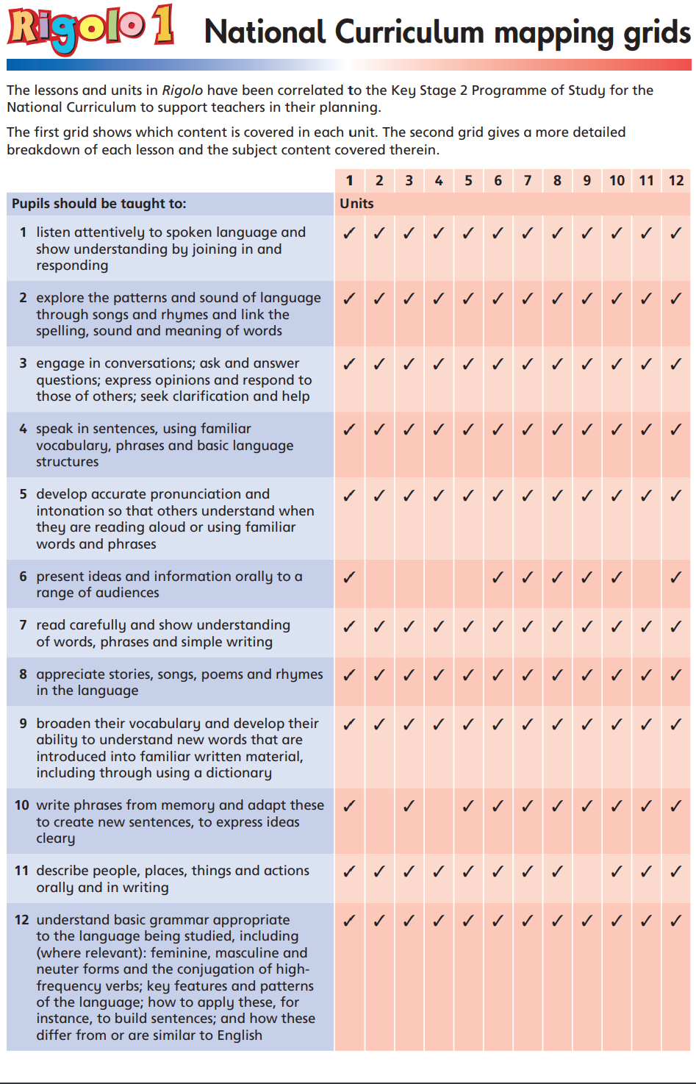
Appendix 3: National Curriculum mapping grid for Rigolo

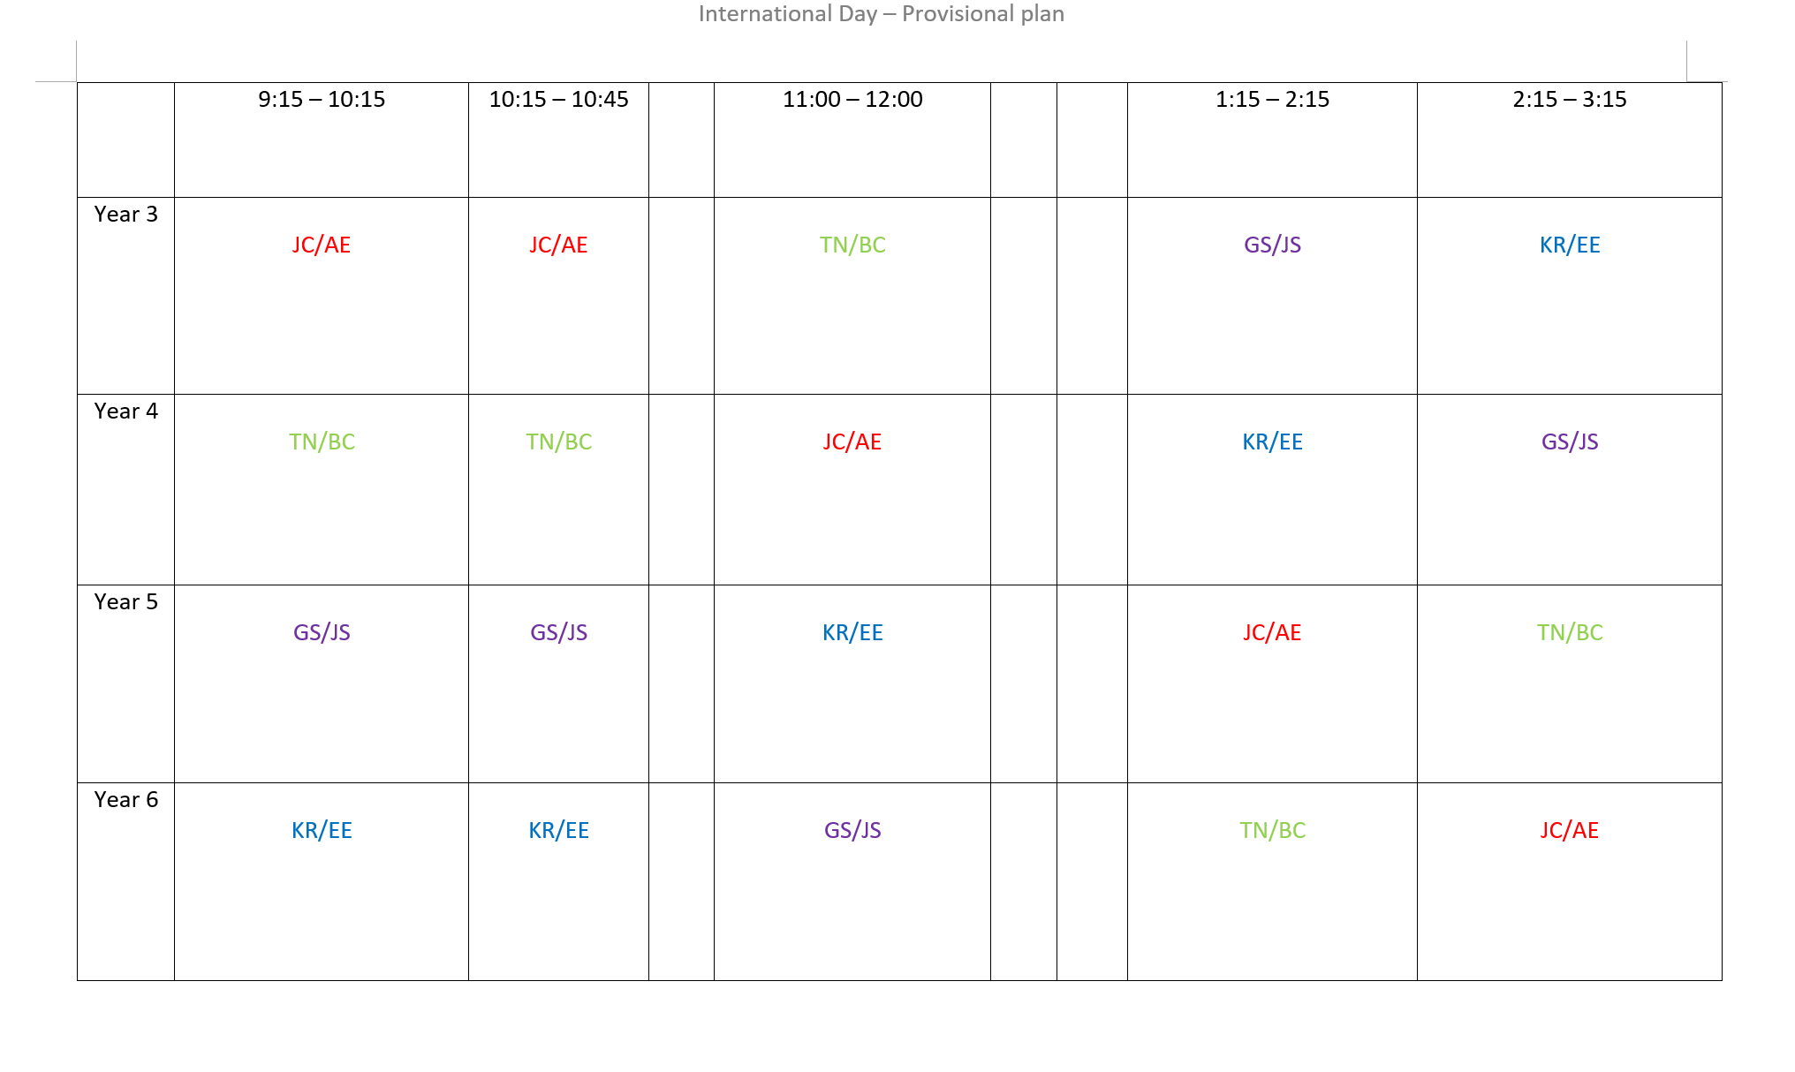
Appendix 4: International Day plan
