
Dear Children,

Who would have thought that we would be starting 2021 like this!? Lockdown number 3 is well and truly upon us and I hope that you are all managing well at home and starting to get into the swing of remote learning. When we were in lockdown number 1, I wrote the weekly newsletter to you – the pupils of Old Catton Junior School. Your parents and carers are receiving so many letters and different forms of communication from school that I think the last thing they need is a newsletter from me! However, keeping in touch with you is so important to me and this is one way that I can do that – as well as dropping into your online lessons which I also plan to do.

Every week we will text your parents and carers a link to your newsletter and we will also post them on the school website so that you can find them easily and read them when you have time.

Online Live Lessons

Firstly – WELL DONE!!! The majority of our pupils are attending their live lessons and completing and submitting work every day. You are quite simply superstars if this is what you have done so far. We are so proud of you for adapting to working in this way. Keep it up!


You have now all received your timetables for your daily live lessons. Your teachers have all been working so hard to make sure that they are giving you the same quality of learning at home, as you would get in school. However, this is hard! And we are all learning together at the moment. In order for things to run smoothly and for your teachers to be able to teach you all from their screens there are a few things I would like you to know and think about.



Your teachers will also have children in their classrooms while they are teaching you online. This can be very tricky! It may feel like you are the only one your teacher is speaking to because you are by yourself but please remember that the whole class are there too – it just may not feel like they are. This means you will need to be patient and still take turns and wait etc like you would need to do in the classroom.

The chat function is really useful in order for you to ask questions to your teacher about the learning. However some pupils have been using this to make unnecessary comments and communicate with other pupils while the learning is going on. As you can imagine, this can be very distracting for the pupils and the teacher. If you are trying to focus and concentrate on the lesson but the chat keeps popping up, you are naturally drawn to read it and this can become unhelpful. Please only use the chat in all areas of Teams for relevant questions.

As we teach you in our e-safety lessons, everything that you write or type or send as a message online should be something that you would be willing to say face-to-face with someone. Therefore manners and respect are still very important online just as they would be in school. Please remember this when you are typing in the chat. (It is also worth knowing that your teachers can see everything that is typed on Teams – so please do not type something that may lead to problems or offend someone else.)

Be kind. Be Respectful. Be polite. Just as you would in person – being online is no different.

You are all working on different devices of different ages and capabilities at home. This means that sometimes work your teachers have set may not appear as we think it will on your device. Your ability to see the live video content and access the online work is affected by so many different technical things, (many of which we do not fully understand yet!) Please be patient with us while we get better at using Teams and knowing what advice and guidance to give you at home.

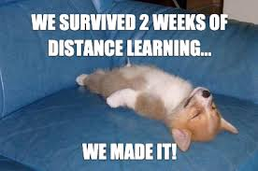

Staying safe online

As you are spending a lot of time online at the moment for your learning but probably also for your social interaction with your friends and family, I wanted to remind you all of the importance of staying safe online. Please make sure that when you are using any kind of social media or chat/video websites that you only use sites that are safe, appropriate for your age and ones that are known and checked by your parents and carers. Remember that you should not talk, chat or send messages, photos or videos to anyone that you do not know.

I like to think about it as if I was in a park, (in real life!) I wouldn’t tell a stranger my name, where I lived, what my hobbies were, where I work and show them all my photos on my phone. If I did that with a complete stranger in real life you would all tell me that I was putting myself in a potentially unsafe position. It is the same online. If you do not know the person – please do not start any conversation with them. As we have taught you, you can’t be sure who anyone is online, even if they tell you things that seem to make sense, it may not be truthful.

We have been alerted to a website that appears to be a chat/video site. It is called www.omegle.com and we have been advised that it is not safe for you to use. Please make sure that if this site is recommended to you, you do not use it.

When you are online, if at any time you feel unsafe or you see something that makes you feel uncomfortable, you must tell an adult straight away. Show them what has made you feel this way and they will be able to help you.
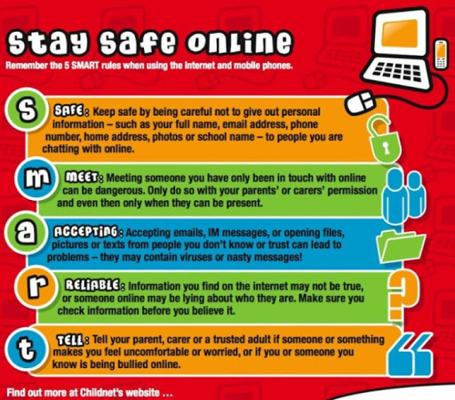

While you are at home, if there is ever anything that you would like to speak to your teacher or another member of staff about, please remember that you can contact us and ask us to call you for a chat or you could send a message or email and we will get back to you.

Our school telephone number is: 01603 426973

Our office email address is: office@oldcatton.norfolk.sch.uk

Weekend Plans!

During lockdown it can be very difficult to make the weekend feel different from the weekdays. Here are some of my tips for making sure that you feel that the weekend is here and your days off feel like a break from your routine.

- You don’t have live lessons or a timetable to follow so you can lie in and slob about in your pjs without having to get ready for your learning!

- Have a wash, get dressed and have some yummy breakfast after you have been able to enjoy a more relaxing start to the day.

- As a family at the weekends we plan some fun things that each of us wants to do. We all decide on something and then make sure that during the day we build in time for each activity. E.g. Daisy may want to play a game altogether (Uno Flip is a favourite at the moment – if you haven’t tried it, I highly recommend it!) Freddie may want to play football in the garden – a coaching session involving all of us can commence. Rob might like us to all watch a film together and I will probably insist on us all going for a walk to get some exercise and fresh air.

- At the weekends you may like to chat to your friends and family. We tend to use facetime or Zoom to keep in touch with our loved ones. It’s great to be able to do this but remember not to spend too much time on a screen. You are using them a lot during the week and having a break from this at the weekend is healthy.

- To make the weekend feel different we have some treats that we wouldn’t have during the week. Daisy and Freddie are allowed to have some sweets or chocolate. (My favourite treat are chocolate buttons!)

- I know that it can be boring being at home a lot. When my children tell me they are bored these are some of the things I tell them to do: Read a book, watch a TV programme, draw a picture, play a game together, find something to play with that they haven’t used for a long time, make a model with their lego, tidy their bedrooms! (I should be so lucky!)


I know it can be hard being at home a lot but trying to structure your days and make the weekend feel different is a great way to keep yourself feeling upbeat and happy. There may be days when you might feel a bit down in the dumps – know that this is normal and we all feel like that from time to time.

I’d love to hear about what you have been up to so please send me an email or a picture to show me!

Take care and have a lovely weekend.
Mrs Connelly
headofschool@oldcatton.norfolk.sch.uk

