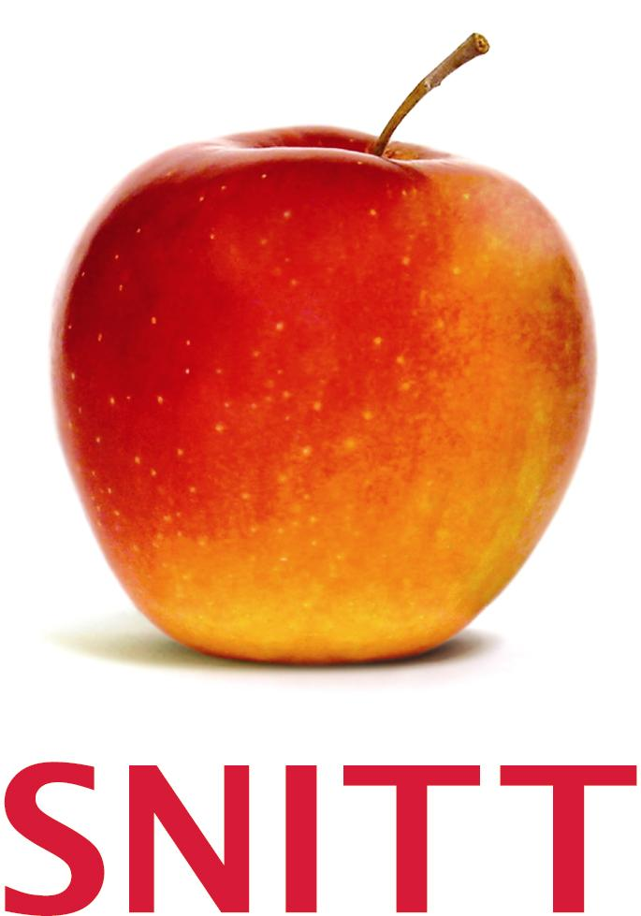
www.snitt.co.uk

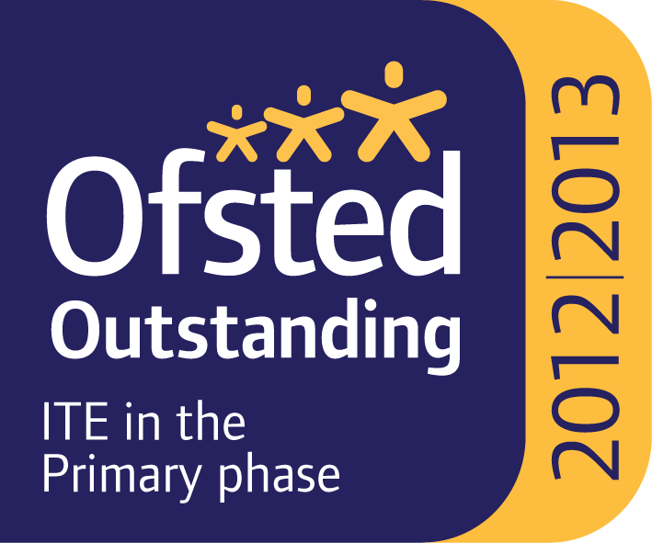
Suffolk & Norfolk Primary SCITT School Direct – a grade 1 provider

White Woman Lane School is a partner with Suffolk and Norfolk Initial Teacher Training. Together we offer you:

- Very high quality teacher training – awarded Outstanding at last Ofsted Inspection May 2013
- Rated in the top 20 nationally in the ‘Good Teacher Training Guide’ in 2011 and 2012 (published by Buckingham University)
- A blend of teaching experience in schools informed by substantial centre-based training
- Superb pastoral support from the SCITT team, as well as the opportunity to work with excellent classroom practitioners to enable you to become the best possible NQT
- A Postgraduate Certificate in Education, Qualified Teacher Status (QTS) and 60 Masters level credits and the academic support to help you achieve this
- The opportunity to excel in teaching – last year 57% of trainees qualified with a grade of ‘Outstanding’
- Excellent employment prospects – 92% took up teaching posts in September 2013 Support and guidance to find the right job for you.

White Woman Lane School is the Lead School but please note that placements may not take place in the named Lead School but in one of its partnership schools locally.

The schools in the consortium are as follows:
- White Woman Lane Junior School, NR6 7JA
- Garrick Green Infant School, NR6 7AL
- Drayton Infant School, NR8 6EP
- Drayton Junior School, NR8 6EF
- Lodge Lane Infant School, NR6 7HL
- Old Catton Junior School, NR6 7AL
Please have a look at their websites for further information about each of the schools

For further details about Suffolk and Norfolk Primary SCITT School Direct, please look on our website www.snitt.co.uk and follow the link to Primary SCITT

